CURRICULUM VITAE
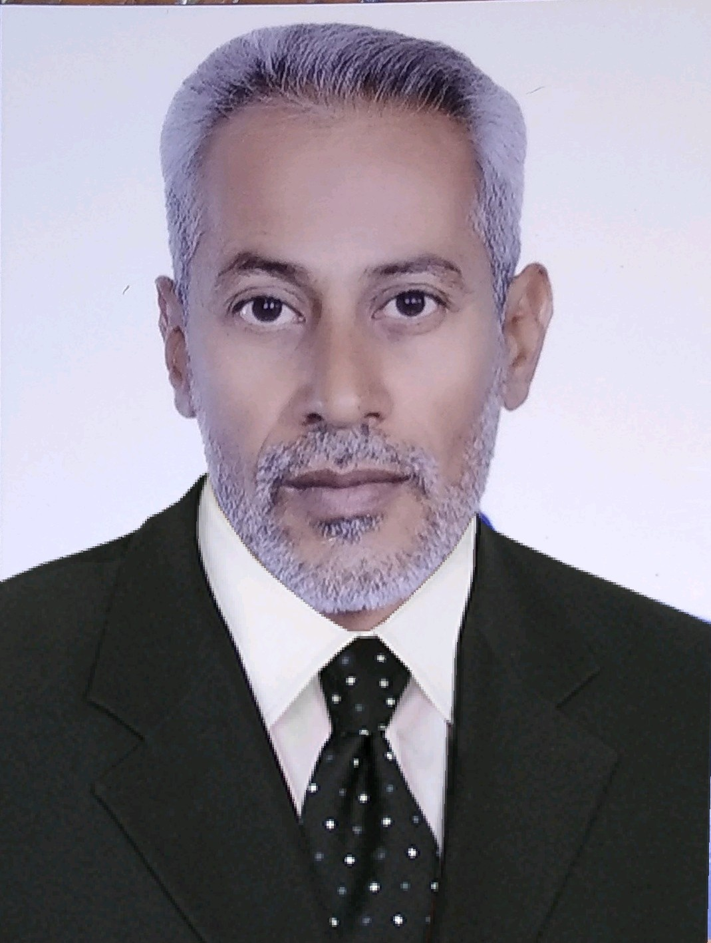

JUMAA KAZIM FINJAN
Mobile: +964-7726824796
E-mail: gnj969@yahoo.com

jumaajumaaalyaqooby@gmail.com

CAREER OBJECTIVE
Looking for a good career, where my creativity and innovation finds their path in a challenging environment which promotes my professional growth, simultaneously help me to Contribute for the growth of the organization by using my skills and abilities.

EDUCATIONAL QUALIFICATION
- Welding and Material from AL-MUATASIM INSTITUTE for Chemical and Mechanical Studies, in 1987.
- Higher secondary from SCIENTIFIC SECONDARY School, BAGHDAD in 2009.
- OSHA 30-Hour Training for Construction Industry from Naya Engineering Services and Training, in 2018.
- OSHA 30-Hour Training for General Industry from Naya Engineering Services and Training, in 2018.
- First Aider, CPR & AED Certificate from Naya Engineering Services and Training, in 2018
- GRV certificate from Sarplast Qatar W.L.L as GRV Supervisor (PW004/PW005/PW006) in 2018

OPERATING AND MAINTENANCE DIESEL ENGINES QUALIFICATION
- Course in Industrial OPERATING AND MAINTENANCE DIESEL ENGINES, GENEARL DIRECTARATE OF ENERGY IN AL-NASIRIYAH, IRAQ.

SOFTWARE SKILL:

- MS office, MS Excel, MS Word.

PROFESSIONAL EXPERIENCES:

Company Name : KMSK GROUP OF COMPANIES-IRAQ
Designation : HDPE PIPING SUPERVISOR & FABRICATOR.
Client : HDGSK  JV (HYUNDAI, GS E&C and SK E&C JOINT VENTURE)
Project Name : KARBALA REFINERY PROJECT
Duration : July 24th 2016 to October 20th 2018.

Company Name : RED SEA COMPANY
Designation : HDPE PIPING SUPERVISOR & FABRICATOR.
Client : HDGSK  JV (HYUNDAI, GS E&C and SK E&C JOINT VENTURE)
Project Name : KARBALA REFINERY PROJECT
Duration : January 28th 2016 to July 12th 2016.

Company Name : BILAD AL-DUHA OIL SERVICES
Designation : PIPING SUPERVISOR & FABRICATOR.
Client : MISAN OIL COMPANY
Project Name : GAS INSUALATION UNIT MISAN
Duration : August 06th 2014 to March 04th 2015.

Company Name : PETROFAC
Designation : PIPING SUPERVISOR & FABRICATOR.
Client : GAZPROM
Project Name : BADRA OIL FIELD
Duration : April 16th 2012 to February 24th 2013.

Company Name : S.C.O.P
Designation : PIPING SUPERVISOR & FABRICATOR.
Project Name : AL-SAMAWA OIL WAREHOUSE
Duration : November 21th 2011 to December 03th 2012.

ROLES & RESPONSIBILITIES:

- Supervised Erection of spools/Piping and supports as per isometrics & Piping general arrangements/standards/special piping support drawings.
- Progress and progress report controlling and reporting to section engineer.
- Raising technical queries for many fouling/miss matching etc.
- Provide assistance to piping supervisor/foremen for critical erection and following them for productivity.
- Experience with pressure piping integrity management programs.
- Understand EPC work process and experience on large projects.
- Expertise in developing and updating projects specification and standard design supervision and construction support.
- Broad scope knowledge of engineering designs and understanding of industry codes, registry requirements and standards and construction methods.
- Ensure that all engineering is carried out to the highest standard and meets the clients requirements.
- Preparation of equipment layouts, piping GADs and piping erection and fabrication and erection of piping of various classes and grade materials.
- Review and witness stage inspections.
- Preparation of checklist/balance work to be done for piping systems/loops with conformity to general arrangements drawings, P&IDS isometric drawings and support std. etc.
- Spool erection arrangements to be made
- After erection of the pipe spools field joints welding arrangements to be done

- Pipe support fabrication and erection as per pipe support drawing
- Develop and maintain engineering standards and specifications related to piping and valves.
- Participate in the development of projects workflows and in- house libraries.
- Work with other engineering discipline on developing piping deliverables, including plot plans, equipment layout etc.
- Manage the projects piping group and co-ordinate the work to ensure that piping deliverables are developed on time and according to schedule.
- Guide all Laminator before lamination work and key-lock joint.
- GRE/GRV- Fabrication and installation at site (Non pressure and pressure line).
- Lamination joint inspection and Barcol hardness checking.
- Responsible to all OWS Line UG-GRV for site inspection and reporting to Management.
- Co-ordinate with client QC and Construction for inspection and related issues.

STRENGTH/SKILLS

- Ability to plan the things well in advance and work accordingly.
- Ability to understand the problem thoroughly, then start working with it.
- Good Team Player.

PERSONAL DETAILS
Name : JUMAA KAZIM FINJAN
Fathers Name : Mr. KAZIM FINJAN
Nationality : IRAQ
Permanent Address : JUMAA KAZIM FINJAN, Al-SAMAWA, IRAQ.
Date of Birth : 30-03-1969
Sex : Male
Languages : Arabic & English.
Marital Status : Marriage

DECLARATION
I hereby declare that the above written particular are best of my knowledge and belief.

Place: JUMAA KAZIM FINJAN
Date:

